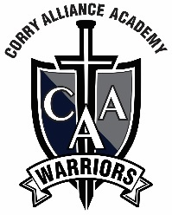
Corry Alliance Academy
721 Hatch Street
Corry, PA 16407
814-664-8658

March 15, 2023
To Whom It May Concern:
It is with my great pleasure to recommend Elaina Wilkinson for a scholarship. Not only am I the principal of Corry Alliance Academy where Elaina has worked as a substitute teacher the past 2 years during her college breaks, but I was also her teacher when she was in 5th grade.
As a student, Elaina is a true leader. She takes on leadership roles and guides her classmates in reaching collective goals. In the classroom as a substitute teacher, she continues to be a leader by effectively completing the lessons and plans left by the classroom teacher.
Elaina has a positive attitude that allows her to accomplish any goal she sets her mind to. No matter the assignment, task or lesson given, Elaina always works at it wholeheartedly and passionately. She strives to always do her best in any task given to her.
I feel certain that you will be just as impressed with Elaina as I am. As an educator who is committed to helping deserving students succeed, I strongly encourage you to consider Elaina for this job position. Please contact me with any questions and let me know if I can provide any additional information in support of this deserving students.
Sincerely,
Ruthann Becker
Ruthann Becker

